

**Matt Smith *Losing Venus***

**Teacher Notes 2020**

**About Matt Smith**

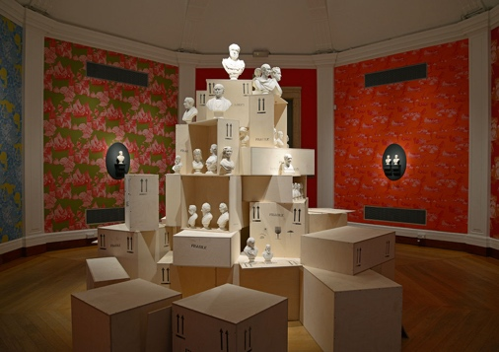

Matt Smith is an artist who works in response to museum collections. Solo shows have included *Flux: Parian Unpacked* at the Fitzwilliam Museum Cambridge and *Queering the Museum* at Birmingham Museum and Art Gallery. He holds a PhD in Queer Craft from the University of Brighton, is Professor of Craft: Ceramics and Glass at Konstfack University of the Arts, Crafts and Design in Stockholm and Honorary Visiting Fellow at the School of Museum Studies at the University of Leicester.

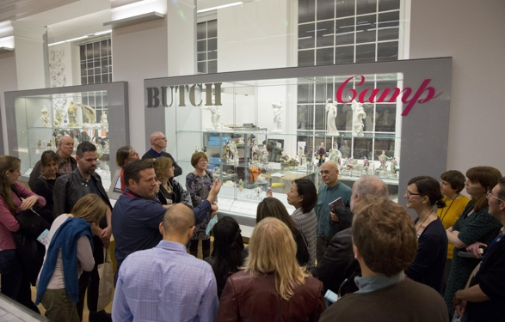In 2016 he was Artist in Residence at the Victoria and Albert Museum and in 2018 he was awarded Work of the Show at Collect at the Saatchi Gallery. His work features in numerous public collections, including the Victoria and Albert Museum, the Walker Art Gallery and the Fitzwilliam Museum

*Flux: Parian Unpacked*

*Cruising the Potteries*

**About Losing Venus**

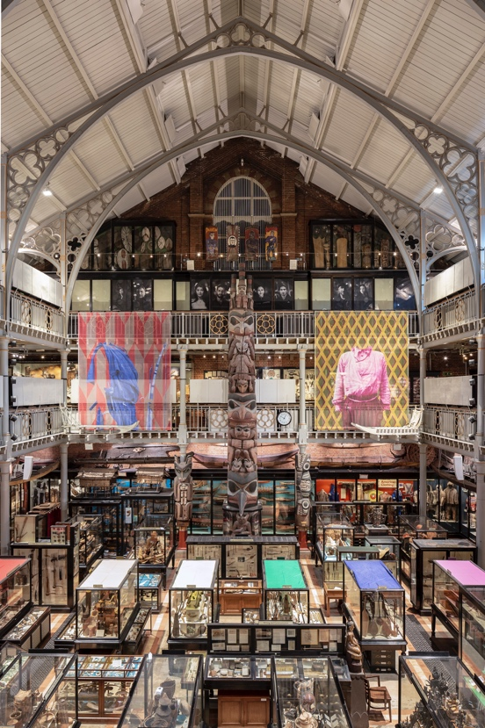

*Losing Venus*, consisting of multiple installations by artist Matt Smith, highlights the colonial impact on LGBTQ lives across the British Empire and seeks to make queer lives physically manifest within the Museum.

250 years ago, Captain Cook set sail to map the transit of the planet Venus – named after the Roman goddess of love - from Tahiti. This information would allow him to calculate the distance of the Earth from the Sun and the size of the Solar System.

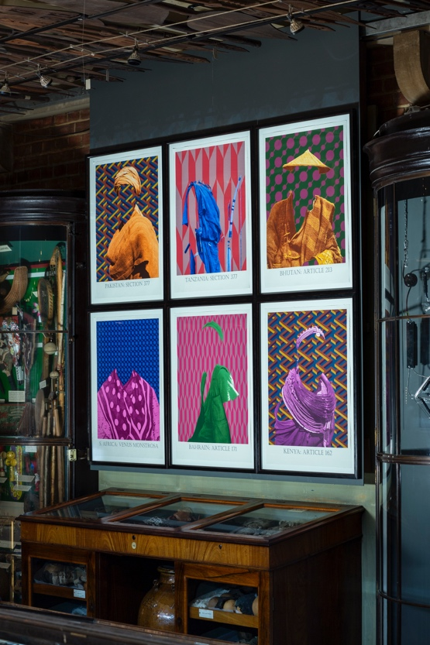This Age of Enlightenment journey was to lead on to British colonisation in the South Pacific and implementation of British colonial laws which outlawed same sex love around the World. What started with a voyage of discovery also led to secrecy, discrimination and erasure, the effects of which are still affecting lives today.

From 1860 onwards, the British Empire criminalized male-to-male relations, imposing lengthy prison sentences and the legacy of these legal codes lives on. Of the 72 countries in the world with anti-gay laws, 38 of them were once subject to British colonial rule.

As a response to these colonialist gender laws, *Losing Venus* seeks to place contemporary discrimination, which is still affecting the lives of many around the world, at the heart of one of the cultural centres of the country which exported it, examining their impact through the lens of sexual identity and gender fluidity.

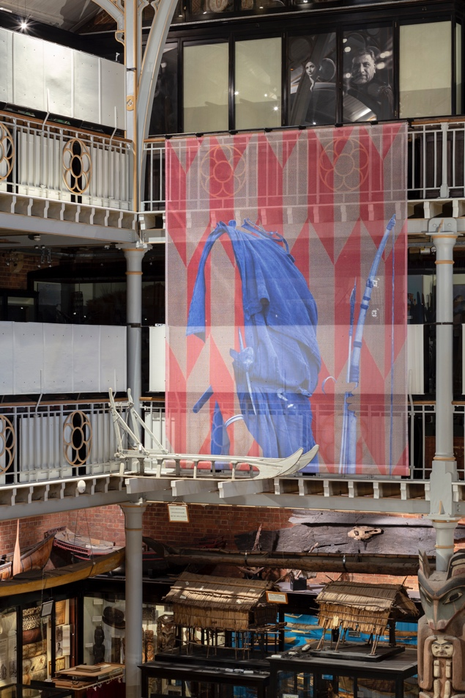**Prints on banners and on Level 1**

The Pitt Rivers Museum has an extensive collection of photographs, including work from the photographer, Henry Evans, whose work illustrates the 19th century desire to record ‘difference’ and ‘scientifically’ measure it. Before Western colonial expansion, lives which fell outside of heteronormativity or gender binaries were an accepted part of society, from the fa’afafine in Samoa to the hijira in India. The imposition of LGBTQ legislation encouraged queer difference to disappear for fear of criminalization.

Working with a screen printing studio, Matt has developed a series of seven prints based on historic photographs in the Museum collections, which were taken in countries where British anti-LGBTQ laws were imposed. Using the scientific grids from the Henry Evans images, these individuals’ identities have been visually erased, using the very grids meant to record them.

Each print is from a country where Britain imposed and/or maintained, homophobic legislation. The museum displays objects that may have been worn or used by LGBTQ+ people in those countries. However, we are unlikely to ever know this for sure since people were forced to hide their sexuality or gender difference. This erasure continues and the effects of British homophobia are still being felt around the world today.

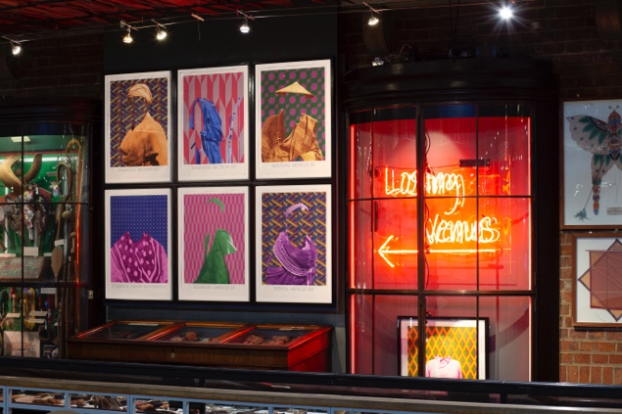

**Dolls**

*‘A common use for dolls is to teach children about adult life, roles, and beliefs’* Pitt Rivers label.

Growing up LGBTQ+, it can be hard to find adult role models. These dolls explore different ways of performing gender and sexuality around the World.

In Brazil, the word deer - *veado* - is commonly used as a slang to insult gay men. Its association is so strong that because the number 24 represents the deer in a popular Brazilian numbers game, many football teams and players refuse to use the 24 shirt to avoid abuse or innuendo.

Sexual relationships between male Samurai were common in Japan, and documented from the 11th century onwards. *Wakashudo* involved adult men and adolescent boys having relationships which often moved into platonic relationships when the youths came of age and it did not preclude the Samurai from marrying women.

In Samoan culture, there is a third gender – fa’afafine. Traditionally, families without female children would sometimes choose a male child to take on female duties and raise them as if they were female. Today, being a fa’afafine is usually the choice of the child and often linked to homosexuality.

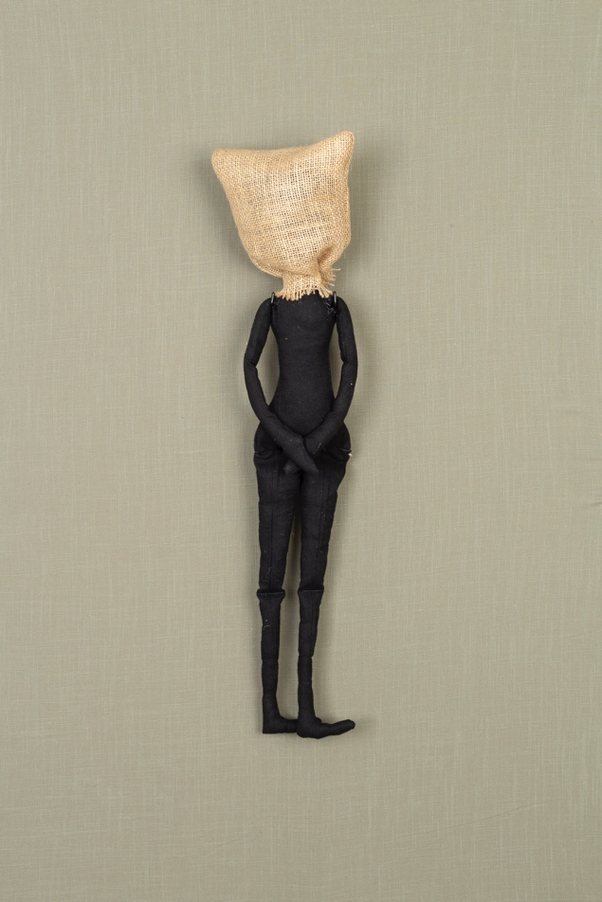

**Dinner Service**

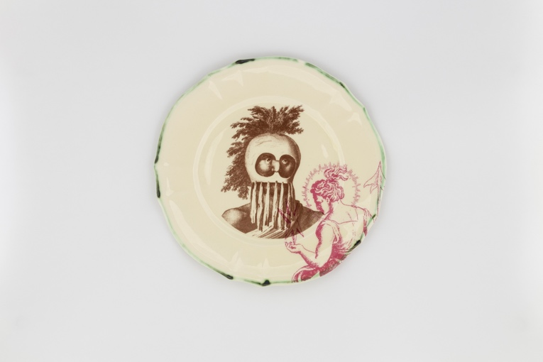

After attempting to map the transit of Venus, Captain Cook’s Voyage continued on from Tahiti to New Zealand and then Botany Bay in Australia. Long seen as a hero in England, Cook is seen by some as a pirate who invaded and started the colonisation of many countries in the South Pacific. This both the discoveries made by Cook and his party and also the weapons used to assert control.

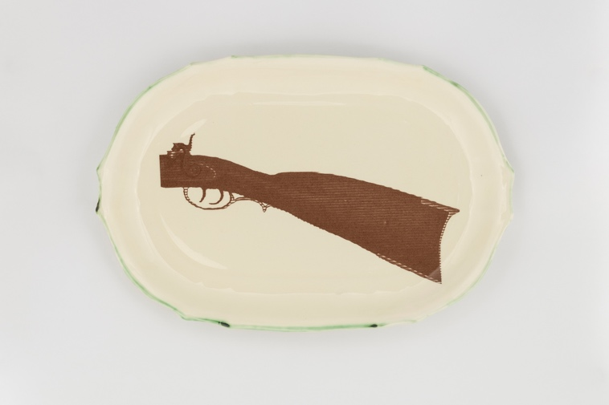In addition to looking for Venus – many of the crew started sexual relationships with local people - often in return for goods or money – which resulted i……n the spreading of European venereal disease. Cook’s voyage of discovery was followed, a century later, by the implementation of anti LGBTQ laws by Britain in many of the countries it occupied – removing the potential for many to find love.